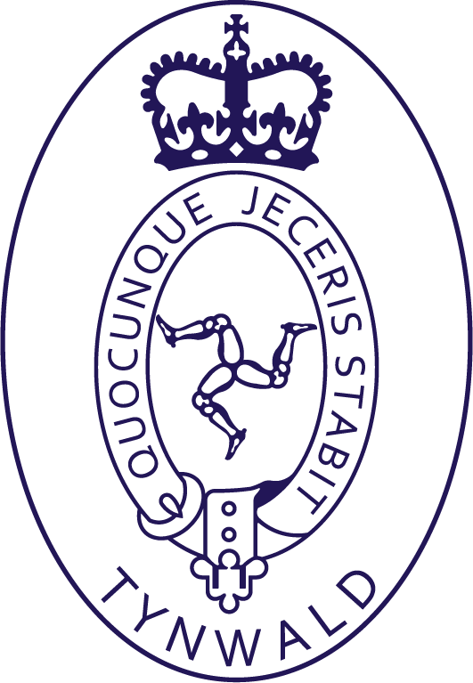 | NOTIFICATION OF SALES
 |  |  |  |  | Date: March 31, 2024
 |  | From | Office of the Clerk of Tynwald  Legislative Buildings  Finch Road  Douglas, Isle of Man  IM1 3PW | To | 23 Church Street  Peel  Isle of Man  IM5 1HN  01624 623821

Supplier Details |  |  | Sales Period | Government Order
Caajryn ny Gaelgey (Friends of the Manx Language) |  |  | EOY 2023-24 | Souv2023-24-1-MGS

Qty | Description | Sale Price
1 | Dunverys er Traen Tappee dy Niar (Murder on the Orient Express) | £14.99 | £14.99
1 | Yn Trollag Manninagh Beg | £2.50 | £2.50
SUBTOTAL |  |  | £17.49
COMMISSION @ 20% |  |  | £3.50
Payment will be made against a Government Order.
Please invoice for the items sold (sale price less 20%) and include the Bank Account details for payment on the invoice:

Name on the account:
Sort Code:
Account Number:

